**Assignment 4**

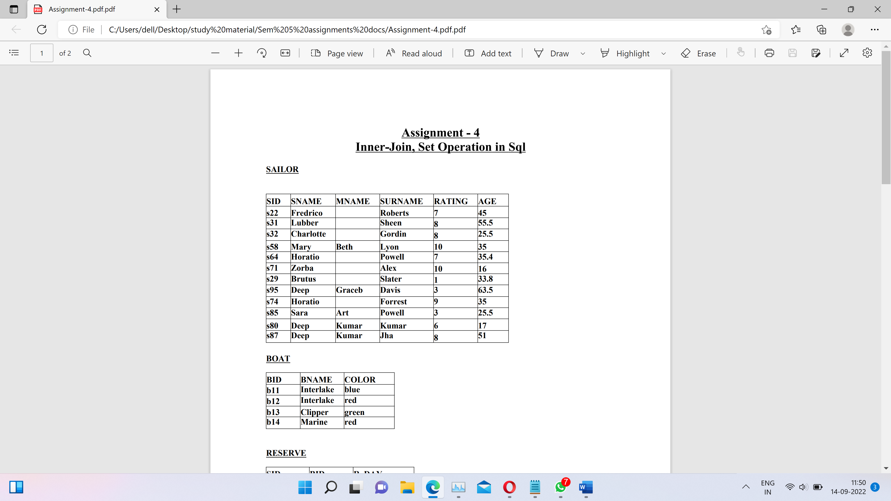

Reserve

|  |  |  |
| --- | --- | --- |
| SID | BID | R_DAY |
| S22 | b11 | 10-OCT-98 |
| S22 | b13 | 10-AUG98 |
| S22 | b12 | 10-OCT-98 |
| S22 | b14 | 10-JUL-98 |
| S31 | b12 | 11-OCT-98 |
| S31 | b12 | 11-JUN-98 |
| S31 | b14 | 11-DEC-98 |
| S64 | b11 | 09-MAY-98 |
| S64 | b12 | 09-AUG-98 |
| S74 | b13 | 09-AUG-98 |
| S80 | b12 | 07-JUL-98 |
| S87 | b11 | 08-JUL-98 |
| S87 | b12 | 12-DEC-98 |

1) Find sid of sailors who have reserved boat ‘b14’

**Query:**

select sid from reserve where bid='b14';

**Output:**

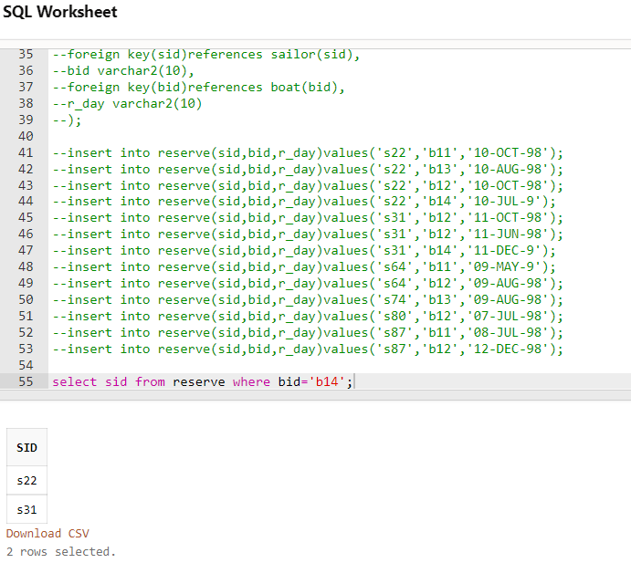

2) Select names of the sailor for whom rating is present.

**Query:**

select sname, mname, surname from sailor

**Output:**

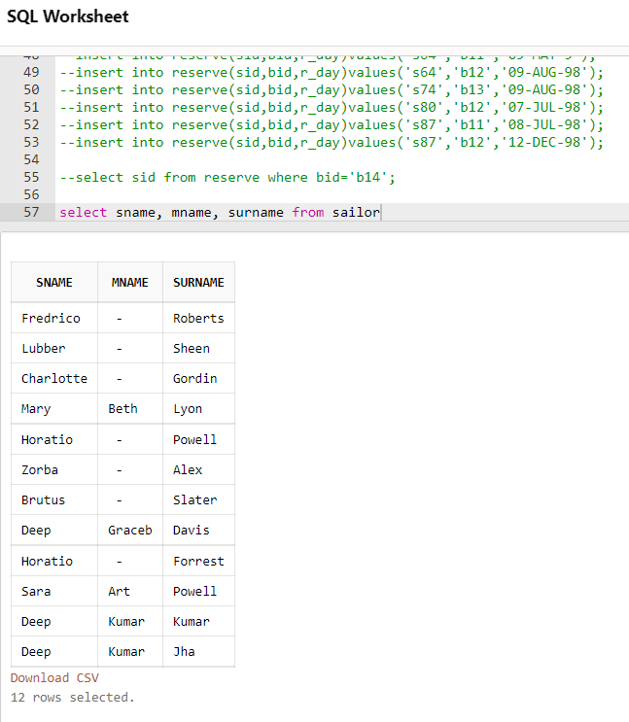

3) Select names for rating absent.

**Query:**

select sname, mname, surname from sailor where rating='';

**Output:**

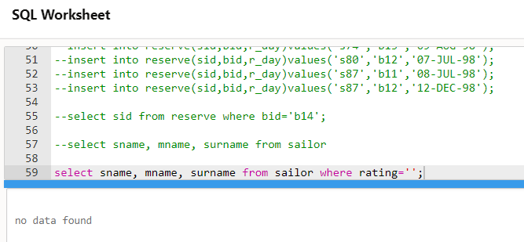

4) Find color of boats reserved by Lubber.

**Query:**

select distinct color from boat,sailor,reserve

where sailor.sid=reserve.sid AND boat.bid=reserve.bid AND sailor.sname='Lubber';

**Output:**

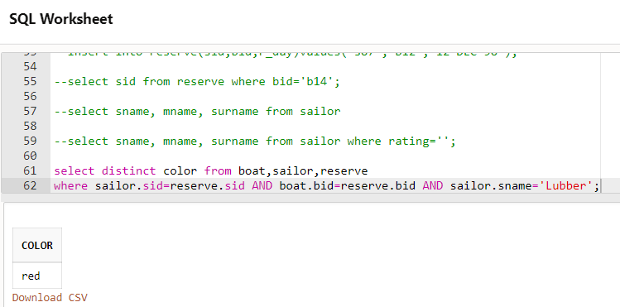

5) Find a sailor name that have reserved at least one boat.

**Query:**

select distinct sname,mname,surname from sailor,boat,reserve

where boat.bid=reserve.bid AND reserve.sid=sailor.sid

**Output:**

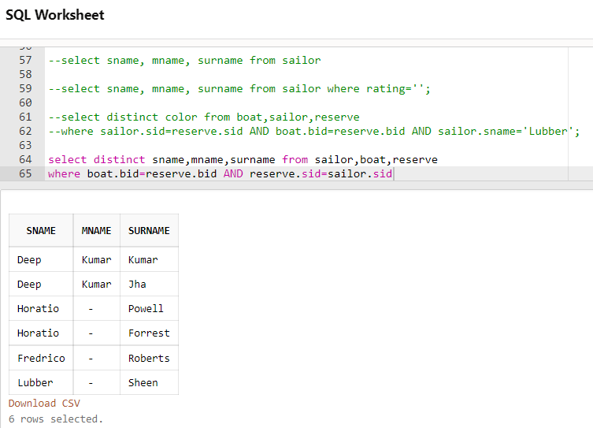

6) Find the ids and names of sailors who have reserved two different boats on the same day.

**Query:**

select distinct s.sid, s.sname,s.mname,s.surname from sailor s, reserve r1, reserve r2

WHERE s.sid = r1.sid AND S.sid = r2.sid AND r1.r_day = r2.r_day AND r1.bid <> r2.bid;

**Output:**

